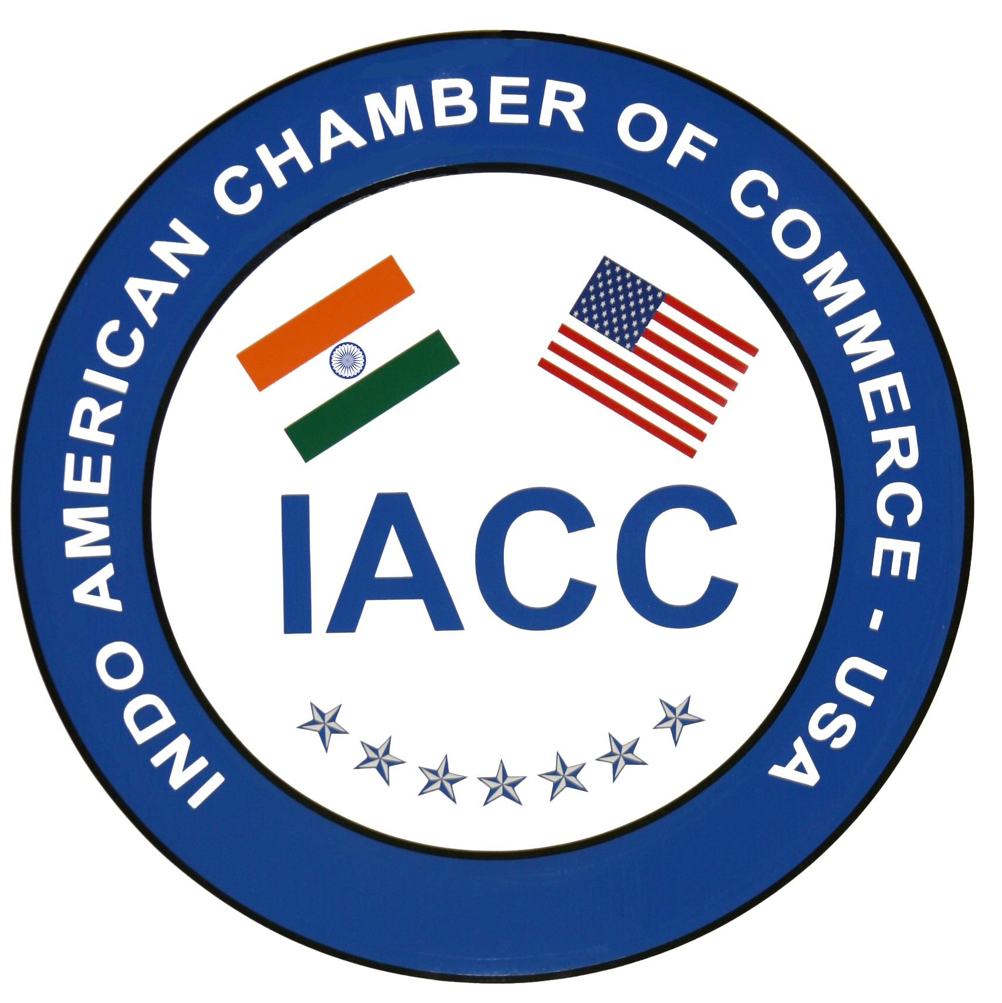

**India Initiative**

The Indo-American Chamber of Commerce USA is proud to announce the launch of the **India Initiative**. Led by IACC Board Members Reshma Sambare (*Miller Canfield*) and Tonya McNeal-Weary (*IBS Global Consulting*), the goal of this new initiative is to create dialogue and exchange between Indian and American companies.

The India Initiative will help to create a platform for Chamber members to connect with India through varies activities including:

* **Roundtable Discussions** with entrepreneurs and business owners from India
* **Meetings with Representatives** from Trade and Industry Organizations based in India
* **Trade Missions** to India where you can meet one-on-one with potential business partners

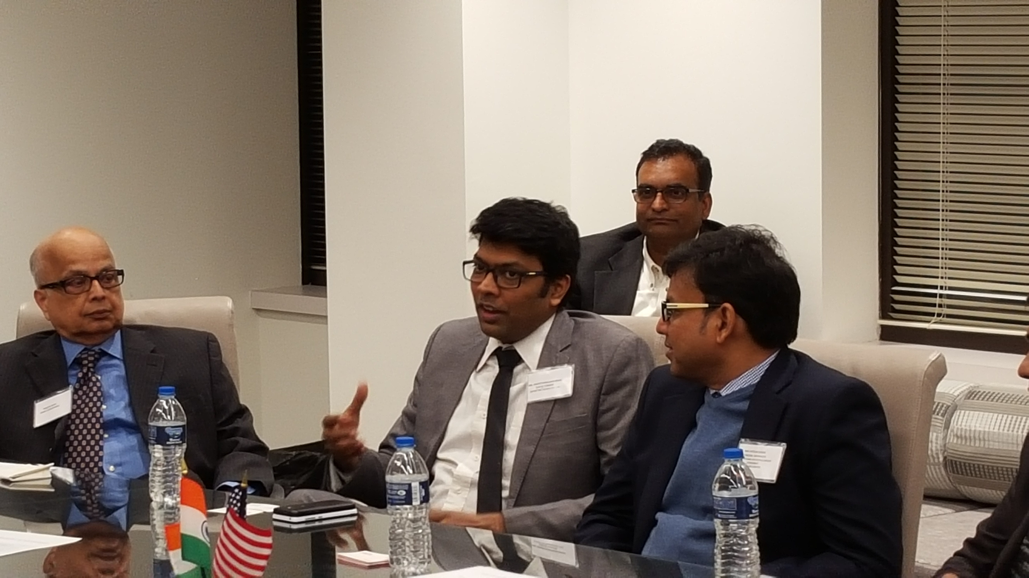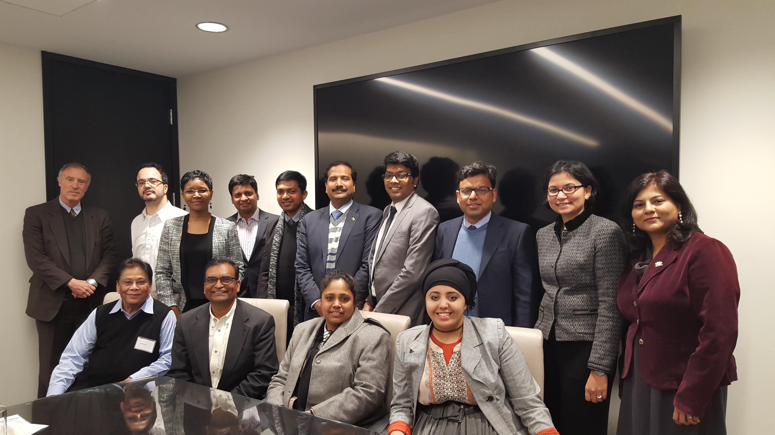

IACC recently hosted a roundtable discussion with a trade and business delegation from India that included representatives from the **World Trade Centre Mumbai**, **Confederation of Indian Industry**, **United** **Nations ESCAP** (Economic and Social Commission for Asia and the Pacific), and entrepreneurs and business leaders from the private sector.

To learn more about the India Initiative or to submit a business matching request, please contact the Chamber via email at **GoIndia@iaccusa.org**.